Change access modifier of method/property/property-get/property-set

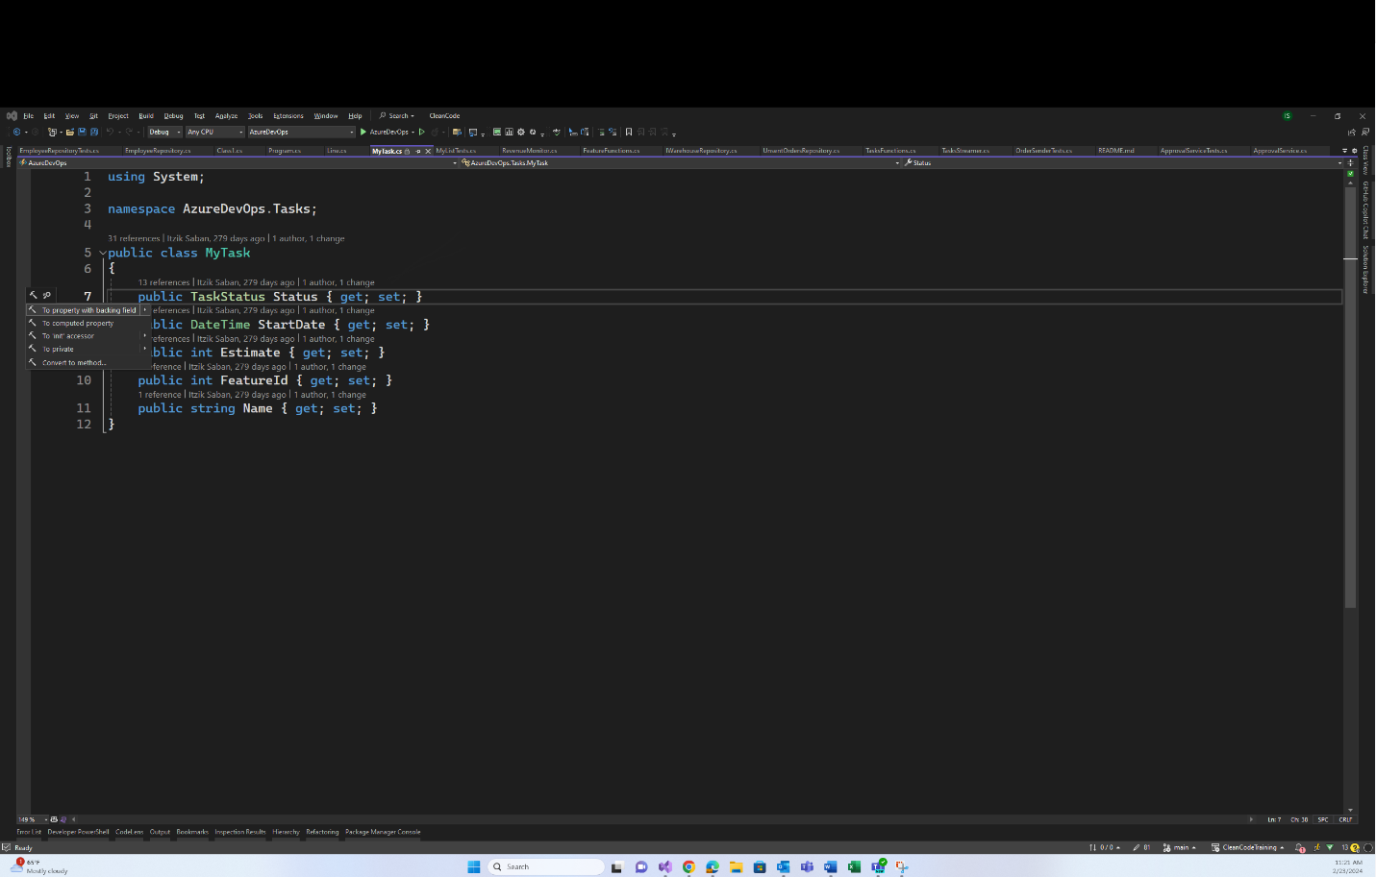

To change the access modifier for the whole property, put the cursor on the access modifier keyword (public/private/etc) and click Alt+Enter, and to change it only for the get or set, put the cursor on the get or set keywords and click Alt+Enter

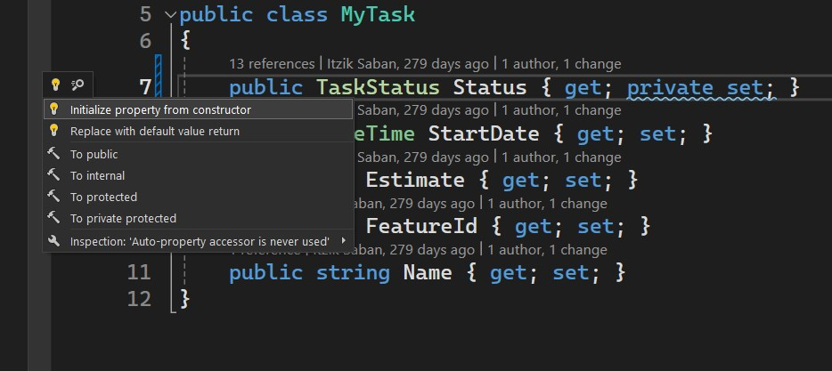Initialize property with private set from the constructor

For properties with private set, the IDE suggests you to initialize it from the constructor. Put the cursor on it and click Alt+Enter

Extract method

Select the whole block you wish to extract to a method and press Alt+Enter. Then select “Extract method…”

Inline method/property/variable/class-member

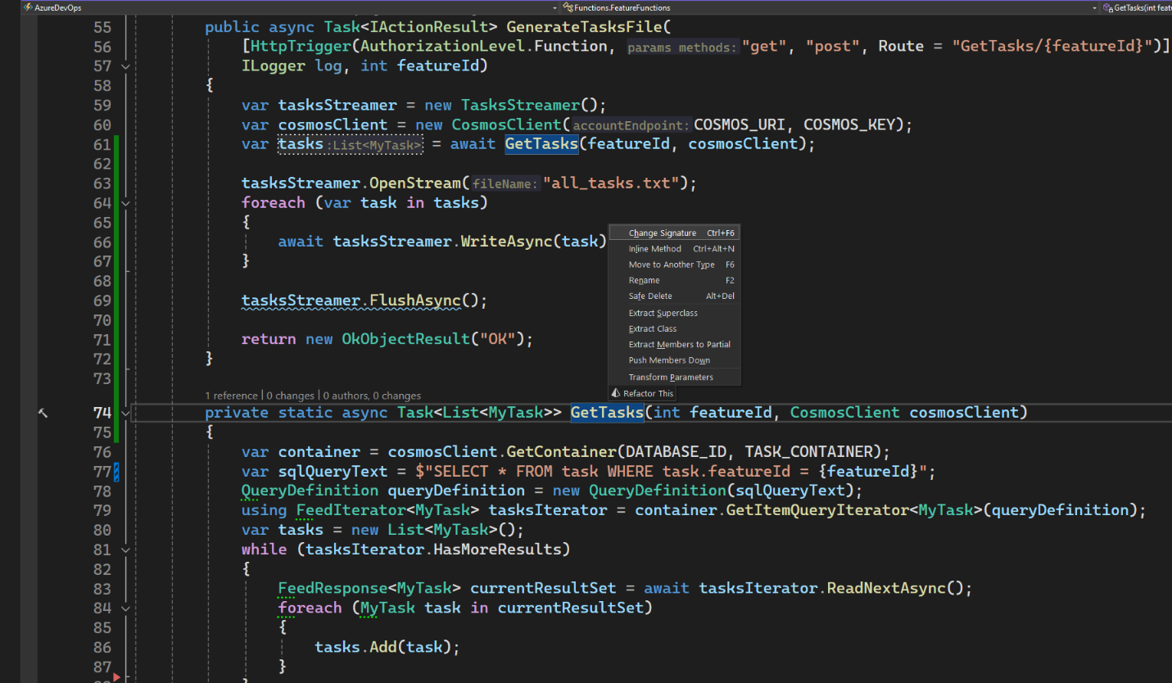

Put the cursor on the method/variable/class-member that you want to inline. Press Ctrl+R and select Inline [method/variable/etc]

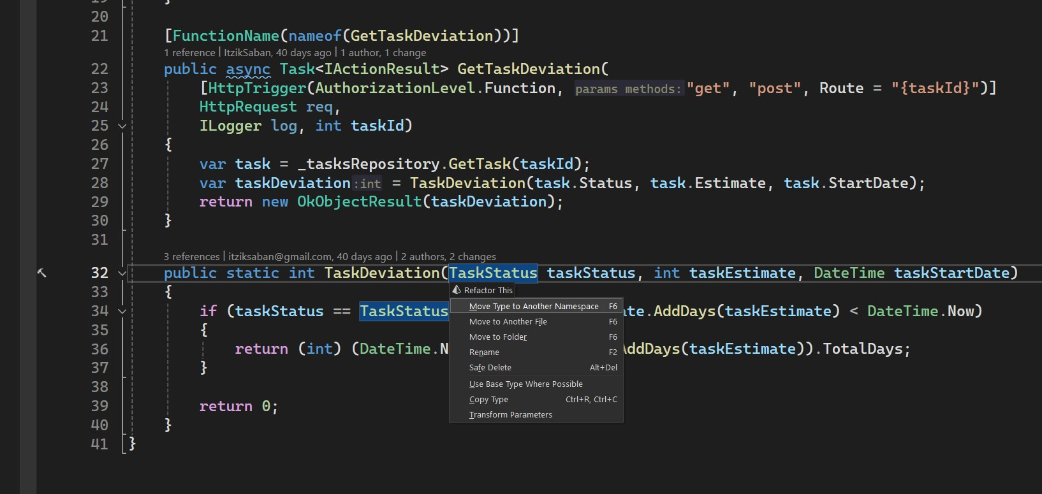Transform Parameters

I

Put the cursor on of the parameters. Press Ctrl+R and select “Transform Parameters”. In the opened window select which parameters do you wish to transform and give the new class a name.

Introduce Parameter

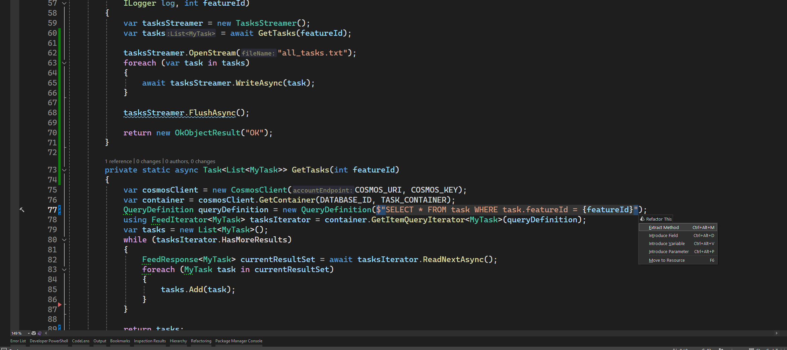

Put the cursor on the value that you want to receive as a parameter and click Ctrl+R. Then select “Introduce Parameter”

Introduce Variable

Put the cursor on the value that you want to extract to a variable and click Ctrl+R. Then select “Introduce Variable”

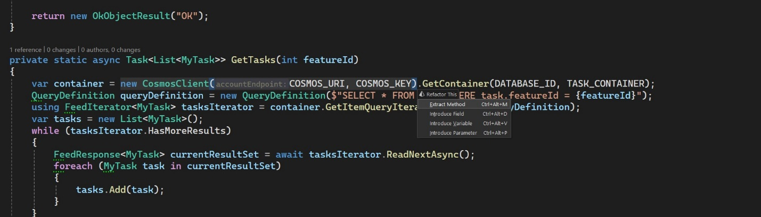

Extract Class

Put the cursor on the class definition that you want to extract a new class from and click Ctrl+R. Then select “Extract Class”

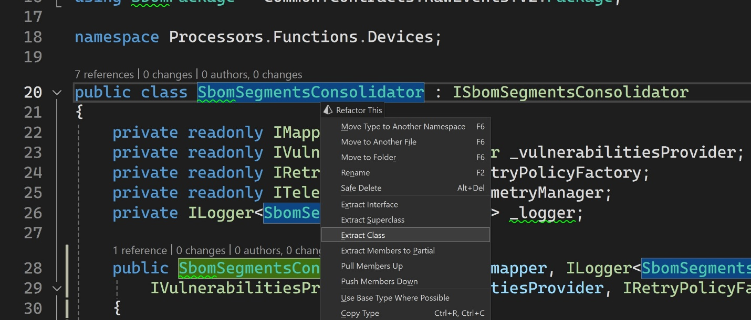

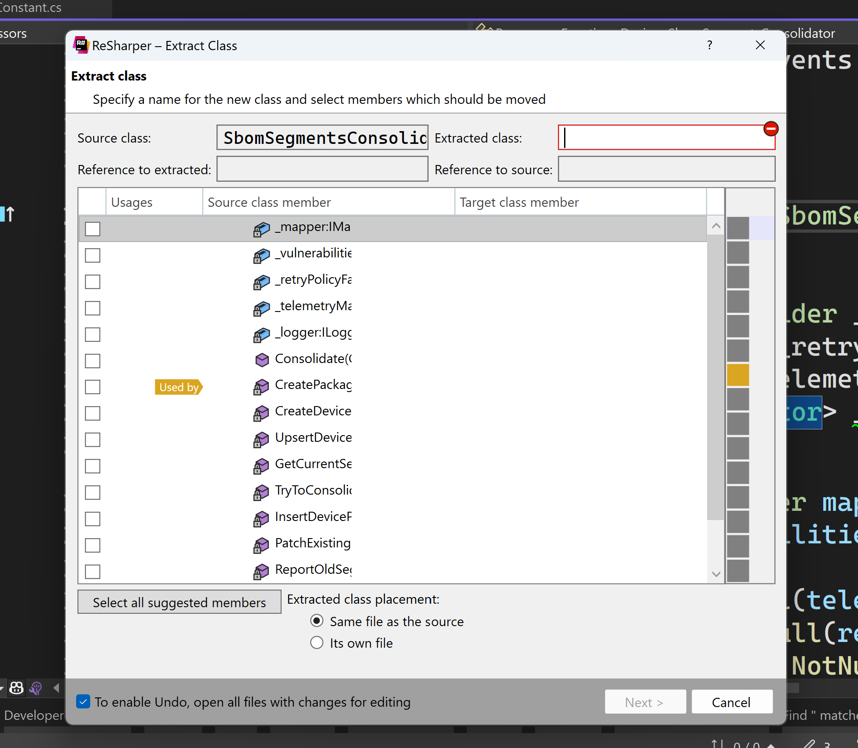

Select which methods/properties/members do you want to extract to the new class

Set the new class’s name